Individual Analysis – Hose

TRAFFIC SIGN CLEANING
Name

Introduction
The project is to make a system that will clean the traffic sign boards but the main thing is that this cleanliness must be done without interrupting the flow of traffic hence the team has designed a solution that will fly in the air like drone and will clean the sign boards, there is a hose present in the design that will help in providing the water from the ground and will also help in providing the fail-safe system. Fail safe system is basically providing the safety feature and ensure that if the drone will fall or stop working then the fail-safe system will run the reel to cover the drone and keep the drone safe from falling.
The analysis present in this paper is talking about the hose system connected with the drone. This hose will fly in the air along with the robot so need to analyze the length of hose and weight that can easily carry by the drone system. It is important to make this system fly in the air along with the drone otherwise the requirements of the project don’t meet.

Assumptions
Assumption used for the analysis are
$$v_{a}=140 knots$$
$$v_{e}=233 knots$$
$$Density of Air=1.225\frac{kg}{m^{3}}$$
$$Area=0.0052 m^{2}$$

Equation
$$F=Density*Area*\left(v_{e}^{2}-\frac{v_{e}v_{a}}{2}\right)$$
In the above equation
$$F=Force in newton$$
$$Area=area of propeller$$
$$v_{e}=proppler speed$$
$$v_{a}=air speed$$
$$density=air density$$

Physical Modeling
For performing the physical modeling of the system, the hose has to built in practical to test if it can fly in the air and how much weight it will have that will carry by the drone but this has not performed. The actual design of the product has shown below:
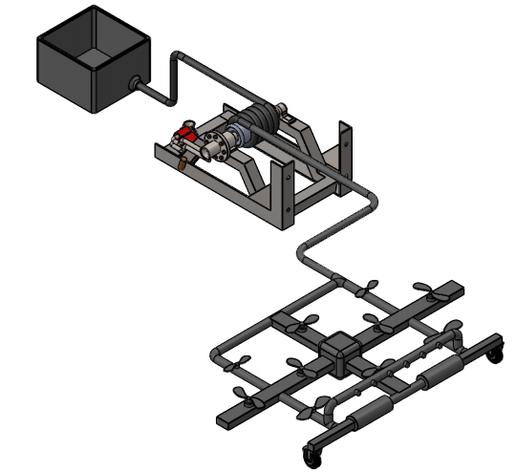
Figure 1: Final Design

Calculations
In the final design, there are 10 propellers present which will rotate and fly the drone in the air, the technique of positioning the drone is 3-4-3, in this way the middle line has 4 propellers which will provide more power to balance all the sides of drone and drone will lift easily. So, calculate the force that will produce by these propellers together.
One propeller can produce the lifting capacity as
$$v_{a}=140 knots$$
$$v_{a}=72.022\frac{m}{s}$$
$$v_{e}=233 knots$$
$$v_{e}=119.866\frac{m}{s}$$
The formula to calculate the generated thrust from one propeller is
$$F=Density*Area*\left(v_{e}^{2}-\frac{v_{e}v_{a}}{2}\right)$$
And the air density is
$$Density of Air=1.225\frac{kg}{m^{3}}$$
So, the area is
$$Area=0.0052 m^{2}$$
And the force is
$$F=1.225*0.0052*\left({119.866}^{2}-119.866*72.022\right)$$
$$F=36.5311N$$
Hence the total 10 propellers can produce the thrust force of
$$F=10*36.5311$$
$$F=360.5311 N$$
Hence these 10 propellers can generate the thrust of 360.5 N. Now determine the total weight that can lift by the propellers
$$F=W=mg$$
$$m=\frac{F}{g}$$
$$m=\frac{360.5311}{9.81}$$
$$m=37.2386 kg$$
Now convert the mass into pound.
$$m=37.2386*2.20462$$
$$m=82.097 lb$$
Now calculate the weight of hose, the best hose to use is vinyl pipe because of its lightweight option. The weight of vinyl hose is
$$vinyl hose weight=20\frac{lb}{100 feet}$$
The above weight is for the ½ inch diameter pipe and hence the weight of 65 feet long vinyl hose is
$$vinyl hose 65 feet weight=\frac{20}{100}*65$$
$$hose 65 wegith=13 lb.$$
And when the water will present in the pipe, the amount of water in cubic inches are
$$volume=π*r^{2}*hose length$$
$$volume=π*{\left(\frac{0.5}{2}\right)}^{2}*\left(65*12\right)$$
$$volume=306.3053 in^{3}$$
Convert the cubic inch water into liters and that will be equal to same amount of kg as well.
$$volume= 5.1 liters$$
$$volume=5.1*2.2 lb$$
$$volume=11.22 lb$$
Hence the total volume of hose along with the water present in it is
$$total weight=11.22 +13$$
$$total weight=24.22 lb$$
So the total weight of device that need to be in the air is
$$drone weight=30 lb$$
$$hose weight=24.22 lb$$
$$Total Weight of System=30+24.22$$
$$Total Weigth of System=54.22 lb$$
Hence the total weight lift by the propeller is 82 lb., and the total weight actually is 55 lb. so it can easily lift up the hose and the drone.

Conclusion
In this paper the hose weight has analyzed and determine the amount weight drone propellers can carry along with the drone. From the analysis it has found that the hose weight including the water present in it is around 25 lb. while the drone weight is 30 lb. so total together it need to carry is 55 lb. while the capacity of propellers is to carry 82 lb. hence this analysis will help the team in finalizing the hose setting in the design.

References
[1] C. Mos, “Vinyl Tubing”, available [online], https://www.comoso.com/uploads/products/downloads/Parker_Comoso_PV_Series_Catalog.compressed.pdf
[2] A. Baba, “6mm Micro DC motor for mini Drone 3.7v 51000rpm, drone motor”, available [online], https://www.alibaba.com/product-detail/6mm-micro-DC-motor-for-mini_60347921815.html
[3] O. Mini, “Water Volume”, available [online], https://www.omnicalculator.com/construction/pipe-volume

